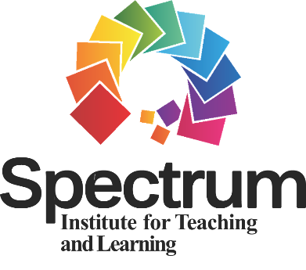
SITL RESEARCH
GRANT PROGRAM

Application Form

Please complete 1–3 and 5-7. ONLY complete 4 and 8 if you are a master’s or doctoral degree student applicant. This application form must be typed and submitted as a word document. Each applicant is limited to submitting one grant application form. Please use 12-point Times New Roman font/type when completing this application form.

1. Eligibility Category (check)
Master’s Degree Student (at least 2nd year standing)
Doctoral Degree Student (at least 2nd year standing)
Early Career Researcher (up to 3 years post-doctoral degree completion)
Later Career Researcher (at least 4 years post-doctoral degree completion)

2. Research Grant Proposal Title (10-word limit)

3. Principal Investigator/Researcher
Name:
Title:
Affiliation:
Address:
Telephone:
Email:

4. Faculty Advisor/Sponsor (only applicable to master’s/doctoral student applicant)
Name:
Title:
Affiliation:
Address:
Telephone:
Email:

5. Co-Investigator(s) (provide the information below for each co-investigator)
Name:
Title:
Affiliation:
Address:
Telephone:

6. Budget Summary
Please insert a summary of the anticipated expenses (100-word limit).
NOTE: This grant program does not allow the use of budgeted funds for indirect costs for project support.

7. Research Abstract (1,200-word limit not including section headings)
Please insert the abstract here using the section headings listed below. Use 12-point New Times Roman font/type. Single space the text and double-space between section headings.

Section Headings for Abstract
a. Purpose of the Research Study – Include the hypothesis and/or research question(s) as appropriate.
b. Background Literature and Theoretical Framework – Include as applicable to the research study.
c. Proposed Study Design and Methodology (participants, research design, data collection, data analysis) – Include as applicable to the study.

NOTE: While in-text citations are appropriate, do NOT include a reference list.

8. Qualifications Statement (only applicable to master’s/doctoral applicant)
Please insert here a 1-page statement written by the faculty advisor/sponsor addressing: (a) the student and faculty advisor/sponsor’s roles in the research study; (b) how the student would make a unique contribution to research through the proposed research study; and (c) the student’s capability to conduct the proposed research study.

Evaluation of Research Abstract
Your research abstract will be evaluated according to the following five criteria:
(a) purpose and research questions and/or hypotheses;
(b) background literature and theoretical framework as applicable to the research study;
(c) proposed study design and methodology (participants, research design, data collection, data analysis) as applicable to the research study;
(d) potential to contribute to and/or impact Spectrum research (i.e., significance of research study to overall research specific to the Spectrum of Teaching Styles); and
(e) clarity of writing.

E-mail the completed 1-page cover letter (as a separate word document labelled LastName Cover Letter SITL Research Grant 2022) and application form (as a separate word document labelled LastName Application SITL Research Grant 2022) to Mark Byra, Chair, Research Grant Review Committee (byra@uwyo.edu) by March 30, 2022. I will acknowledge the receipt of your application materials when received.

